How does EAPA help to implement Asphalt 4.0?
Breixo Gomez. European Asphalt Pavement Association (EAPA). breixo@eapa.org

1. The new EU policy and the necessary change in the construction paradigm
With the arrival of the new European Commission Administration (led by Ursula von der Leyen) in 2019, the most ambitious environmental objectives of history were stablished in the so-called European Green Deal [1]. These objectives included the reduction of net greenhouse gas emissions by at least 55% by 2030 (compared to 1990 levels) and Europe becoming the first climate-neutral continent by 2050. In this document, it is also stablished that the EU should also promote and invest in the necessary digital transformation and tools, as these are essential enablers of the change.
With the aim of developing previous objectives in the European industry, while driving its competitiveness and sovereignty, the Commission adopted in March 2020, a new Industrial Strategy [2]. This highlights the need to promote an inclusive recovery from the pandemic and further accelerate the green and digital transitions in line with the EU Green Deal and Digital Decade and increase the resilience of EU industrial ecosystems.
These ideas were further developed over a series of following legislative initiatives, such as the New Circular Economy Action Plan (March 2020) [3], the 2030 Digital Compass (March 2021) [4], The European Climate Law (June 2021) [5] or the “Fit for 55” legislative package (July 2021) [6].
It is important to highlight that in all these documents, sustainability and digitalisation are not seen as separate and independent concepts. On the contrary, and as stated in the 2030 Digital Compass, “the uptake of digital solutions and the use of data will help in the transition to a climate neutral, circular and more resilient economy”.
In order to achieve this, the strategy defined in the document for the coming is mainly based on 4 principles, the first two focused on digital capacities in infrastructures and education & skills, and the two other on the digital transformation of business and public services.
Among other aspects, the 2030 Digital Compass also identifies the Construction sector as “the lowest productivity development from all major sectors in the last 20 years” and states that according to 70% of construction executives, new production technologies and digitalisation will be the drivers of change in the sector.
In addition, in a Staff Working Document [7] published in December 2021, the Commission describes the scenarios for a transition pathway for a resilient, greener and more digital construction ecosystem. In this document, it is mentioned that in the light of technological development, demographic and climate change and globalization, the world of work is changing. The trend of automation replacing labour and ageing population on one side and migration and mobility of workers on the other, alongside the transition towards sustainable economic growth is reshaping the future of work and altering the need for skills in all industrial ecosystems. Construction, being a particularly labour-intensive and one, is of course not left untouched.
The talent pool for the construction ecosystem is shrinking with ageing workers retiring and young people being reluctant to consider construction as their career choice. The situation is complicated further by the challenges of adapting and upgrading the skills and abilities of the current labour force. Industrial stakeholders often stress the needs to invest in lifelong learning and digital working practices, in better working conditions and social protection, in a healthier and safer working environment and in better promotion of career opportunities; all these would also improve the sectors attractiveness to qualified workers and talent.
Addressing the current skills gap (particularly in digitalisation) and anticipating future skills needs in the construction sector will mean providing more, better and safer jobs.

2. The new mobility
The number of people killed in road crashes around the world continues to increase. According to the World Health Organisation’s “Global Status Report on Road Safety” [8], it reached 1.35 million in 2016 alone. This means that, worldwide, more people die as a result of road traffic injuries than from HIV/ AIDS, tuberculosis or diarrhoeal diseases. And road crashes are now the most common cause of death for children and young people between 5 and 29 worldwide. Compared to the global situation, Europe is doing relatively well, thanks to determined action at EU, national, regional and local level. Between 2001 and 2010, the number of road deaths in the EU decreased by 43%, and between 2010 and 2019 by another 23%.
However, 22.800 people still lost their lives on EU roads in 2019 [9]. As explained in the EU Road Safety Policy Framework 2021 - 2030 [10], this is unacceptable and unnecessary human and social price to pay for mobility. As a response to the situation, the EU adopted new approaches, such as Vision Zero and Safe System.
Research showed that human error causes over 90% of accidents [11]. As autonomous vehicles remove the need of a driver, they could significantly improve road safety. Among other characteristics, automated vehicles have potential to respect traffic rules better than humans and react quicker. In addition, these vehicles can also impulse the car-sharing, helping to reduce congestion, making car ownership in cities less attractive and fostering new and improved business models (i.e. mobility as a service) [12].
The EU has already adopted strategies on cooperative intelligent transport systems [13], as well as on 5G communications technology [14] and data protection rules. Unlike other parts of the world, much of the necessary legal framework is already in place in the EU, serving as a benchmark for international harmonisation with international partners in the United Nations Economic Commission for Europe.
In addition, reducing CO₂ emissions is another priority of the EU and a global challenge that affects us all. In this sense, according to the European Automobile Manufacturers Association (ACEA) [15], self-driving vehicles will help not only to save costs and make roads safer, but also to lower emissions. The transport sector must be firmly embedded in an economy-wide carbon-reduction framework, while also working to maximise CO₂ reductions through an integrated approach linking technology, energy, government and consumers.
In this regard, electric vehicles will also play a crucial role. According to ACEA, e-mobility will also need significant simultaneous investments by a variety of players to ensure that barriers to market acceptance are tackled and to realise electro-mobility’s potential. Hence, an integrated approach is necessary, addressing all the ways for reducing CO₂ with all the relevant stakeholders, not just vehicle technology.
For these reasons, the roads of the future need to be adapted to all these changes in mobility, making them able to (among other things) communicate with connected vehicles about dangerous spots (e.g. barriers), traffic disruptions, traffic signs (speed limits, traffic lights, etc.), available lanes, road conditions (e.g. ice, rain, etc.) or spots with high number of accidents. They may also offer infrastructure for vehicle-to-vehicle communication and even driving support. On the other hand, electric roads may be able to harvest energy (solar, thermal, mechanical, etc.), supply electricity to electric vehicles, supply electricity to road equipment (signals, traffic lights, communication systems, etc.), supply heat to buildings nearby and reduce ice formation by reversing previous systems.

3. Asphalt 4.0
The response of the asphalt paving industry to previous changes/challenges is what is called “Asphalt 4.0”, a concept strictly linked to the wider concept of “Industry 4.0”. This refers to a series of smart and autonomous systems fuelled by big data, machine learning, artificial intelligence, blockchain, internet of things (IoT), etc. with capacity to significantly push forward the efficiency, productivity, quality, reliability and sustainability of a given industrial sector.
The application of these technologies to the asphalt paving sector is known as Asphalt 4.0 and involves the use of digital tools to automate, monitor and improve the way, in which organisations develop conventional activities, such as management of asphalt plants, manufacturing of bituminous mixtures, transport/supply or installation (e.g. laying, compaction, etc).
An adequate Asphalt 4.0 transformation process can result in greater efficiency of the organisation, better guarantees and durability of the offered products and services, savings of time and resources, a permanent innovation process and a totally different way of managing customer satisfaction (costumer experience).
It can also facilitate and accelerate the transition of the mobility sector towards new users, such as electric and automated vehicles.
To reach these objectives, Asphalt 4.0 is based on 3 pillars:
- Digital technologies and tools for the safe, effective and efficient data management, which includes its generation, storage and transfer.
- Smart management systems able to process all data obtained and identify patterns, which will lead to optimum decision making and in a timeframe, which would not be reasonably feasible for humans.
- Customer experience: Roads are not just delivered after construction, but monitored, managed and maintained based on the instant information that is being received and the resulting optimum strategy.
The development of the Asphalt 4.0 concept affects all areas of the organisation and for this reason it should be directed at the highest level.

4. EAPA support to Asphalt 4.0 initiatives
In the past, digital technologies and developments were usually discussed within the agenda of the EAPA Technical Committee. However, due to the significant increase of this content over the last years, EAPA launched, in January 2020, a brand new and specific Committee for Asphalt 4.0.
Overview of EAPA Committees
The main objective of this Committee is to identify relevant technologies, initiatives, projects, etc. being developed around the world and share this knowledge among EAPA Members.
As part of this, external speakers are often invited to the meetings to share their knowledge and experience on new digital technologies. Examples of these were Francisco Vea, from (BECSA), who presented a new digital system to monitor pavement condition and support decision making within the road maintenance plans; and Riccardo Viaggi (CECE), who presented the DigiPLACE Horizon 2020 project on the digitalisation of construction machinery.
EAPA also works to create external awareness among related stakeholders, Public Administrations and general society about the benefits, challenges, barriers for implementation, EAPA position, roadmap, etc. for Asphalt 4.0 technologies.
One of the first actions in this regard was the full renovation of the EAPA website (www.eapa.org), in which among many other things, new sections on “Asphalt 4.0” [16] and “Innovation” [17] were included. In these, a formal definition of the Asphalt 4.0 concept was given, as well as a long list of digital technologies available for all the stages of the pavement construction and maintenance, from the asphalt plant, delivery trucks, pavers and compactors, to the smart management systems that can optimise both the construction and maintenance of road pavements.
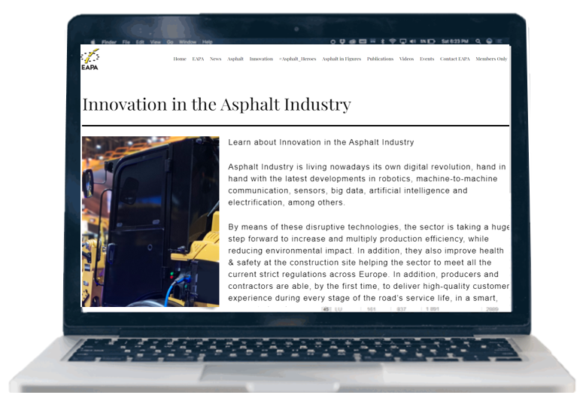
Innovation section on the EAPA website
Another main activity is the publication of documents that can be downloaded for free on the EAPA website. The following two are directly related to the concept of Asphalt 4.0:
- The document titled “Classification of Readiness of European Highways for Adopting Connected, Automated and Electric Vehicles” proposes a classification of roads (or stretches of these), which can give, in a simple way, information to the driver and/or vehicle about the available technologies supporting the automated and electrified driving. At the same time, the key parameters necessary to grant the road/stretch with a given class, are given. Hence, Road Authorities can refer to the proposed classification to determine the necessary actions to be implemented in order to make possible the circulation of vehicles under a desired level of automation and electrification.
- The two documents (a Technical Review and a Technical Briefing) on “High-performance pavements – adapting for future road networks”, analyse some potential risks of the new mobility (automated, electric and heavy-duty vehicles), which could reduce the durability of the roads and how the asphalt industry is getting ready for this challenge.
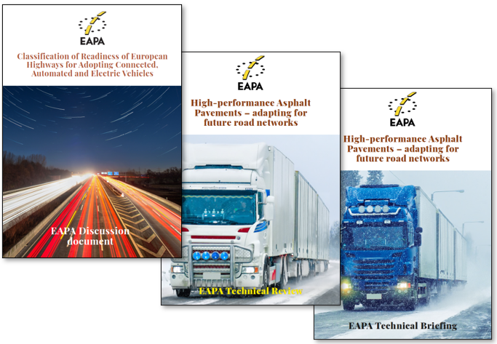
EAPA documents related to Asphalt 4.0 available on the EAPA website
Further related information to the concept of Asphalt 4.0 has been made available in the format of videos, which can be seen on the EAPA YouTube channel [18]. In this, EAPA periodically publishes informative videos (e.g. during the last E&E Congress), Tech Talks and interviews, video briefings on current hot topics, as well as video presentations from Congresses and Webinars. Part of these videos is the series named “Generation Asphalt” in which interesting topics of the asphalt industry are explained to the general public in an easy language. Examples of these are the videos on “What is Asphalt 4.0”? and “Are the roads prepared for the new mobility?” [19].
EAPA videos on Asphalt 4.0 available on the EAPA YouTube channel
The EAPA Communication has also nowadays completed its full digitalisation through social media, a communication means, which has proven to be effective and efficient in reaching every kind of stakeholders involved in the road sector, from industrials and Road Administrations to the general public, road users and, especially, young generations.
Finally, every 4 years EAPA co-organises with Eurobitume the E&E Congress. The latest edition, held digitally in 2021, gathered 800 bitumen and asphalt professionals from 48 different countries around the world. This year, by the first time, the main theme of the Congress was “Asphalt 4.0 for Future Mobility” and specific sessions on the topic were included, such as the session “Future Roads and Mobility”.
On 14-15 November 2022, EAPA and Eurobitume will also organise the so-called E&E Event. The final programme has not been yet published but the topic of Asphalt 4.0 will be included, for sure.
E&E Event 2022
Conclusions
Asphalt 4.0 is the response of the asphalt paving industry to the strong changes that European policy, mobility and society are experiencing nowadays. The digital technologies involved in this concept, have capacity to significantly push forward the efficiency, productivity, quality, reliability and sustainability of the sector. The change is so important, that EAPA launched in 2020 a specific Committee on this topic. Since then, numerous activities and initiatives have been, or are being undertaken to help stakeholders to assimilate and implement these digital technologies in the paving sector.
References
[1] https://ec.europa.eu/info/strategy/priorities-2019-2024/european-green-deal_en
[2] https://ec.europa.eu/info/strategy/priorities-2019-2024/europe-fit-digital-age/european-industrial-strategy_en
[3] https://ec.europa.eu/environment/strategy/circular-economy-action-plan_en
[4] https://futurium.ec.europa.eu/en/digital-compass
[5] https://ec.europa.eu/clima/eu-action/european-green-deal/european-climate-law_en
[6] https://eur-lex.europa.eu/legal-content/EN/TXT/PDF/?uri=CELEX:52021DC0550&from=EN
[7] https://ec.europa.eu/growth/consultations/scenarios-transition-pathway-resilient-greener-and-more-digital-construction-ecosystem_en
[8] World Health Organisation (2018), “Global Status Report on Road Safety”: https://www.who.int/violence_injury_prevention/road_safety_ status/2018/en/
[9] https://ec.europa.eu/transport/road_safety/system/files/2021-07/asr2020.pdf
[10]file:///C:/Users/User/Desktop/EU%20documents/EU%20road%20safety%20policy%20framework%202021-2030.pdf
[11] Commission's report on Saving Lives: Boosting Car Safety in the EU, COM(2016) 787.
[12] https://eur-lex.europa.eu/resource.html?uri=cellar%3A0e8b694e-59b5-11e8-ab41-01aa75ed71a1.0003.02/DOC_1&format=PDF
[13] http://eur-lex.europa.eu/legal-content/EN/AUTO/?uri=CELEX:52016DC0766
[14] https://eur-lex.europa.eu/legal-content/en/TXT/?uri=CELEX%3A52016DC0588
[15] https://www.acea.be/press-releases/article/driverless-trucks-newreport-maps-out-global-action-on-driver-jobs-and-lega
[16] https://eapa.org/innovation-2/
[17] https://eapa.org/asphalt-40/
[18] https://www.youtube.com/channel/UCzPUFc2PJoLc0zBr6BXQ1bA
[19] https://www.youtube.com/watch?v=pxzNTGP8hsc

