EAPA Asphalt Excellence Award

For the first time ever in the year 2021 EAPA awarded outstanding work and research related to asphalt pavements or asphalt industry or EAPA Committees with the EAPA Asphalt Excellence Award. The honoured person should be a member of EAPA or an EAPA Committee and is selected by the EAPA Secretary General and two representatives of the EAPA Technical Committee and two representatives of the EAPA HSE Committee. The trophy for the award winner is presented during a major event of or with participation of EAPA.
The 2021 EAPA Asphalt Excellence Award was granted to Jiří Fiedler, representing the Czech Contractors Association in EAPA and André Täube, Director of the German Asphalt Pavement Association DAV.
Jiří Fiedler has been very active for more than 20 years in the committees of EAPA. His first meeting was in 2001 and since then he supported all kinds of EAPA Committees, e.g. the Technical Committee and the Health, Safety and Environment Committee. Jiri has always been a very active person in these meetings. He was well prepared, always had a strong opinion on a topic and sometimes even his own agenda for the meetings and topics. Meetings with him were always inspiring, fruitful, and challenging. Many studies have been summarised and explained by Jiří to the colleagues, and he always volunteered to do some extra work and the outcome for EAPA was always excellent. He knows the details and we could always count on him. His expertise is highly appreciated and accepted in EAPA and he never missed to explain the participants of the meeting that “I am just the retired guy from Czech Republic, but in my opinion …”.
André Täube has been very active for more than 18 years in the committees of EAPA and has done great work for the Asphalt Industry. His first meeting in EAPA was in 2004 and since then he heavily supported the EAPA committee work especially in the EAPA Technical Committee. André has participated in almost every TC meeting since then. He was always well prepared and had a strong opinion on the relevant topics. Everybody remembers and will remember his high pile of printed documents sorted in a typical German folder for every meeting. His expertise from the German point of view and experience is highly appreciated. In his role as director of the German Asphalt Pavement Association (DAV), member of EAPA, he is excellently serving the German Asphalt Industry since more than 18 years.
It has always been a pleasure for EAPA Staff and EAPA Committee members to work jointly with both experts through all these years and we hope that this fruitful alliance goes on for many more.
The 2021 EAPA Asphalt Excellence Award is well deserved!
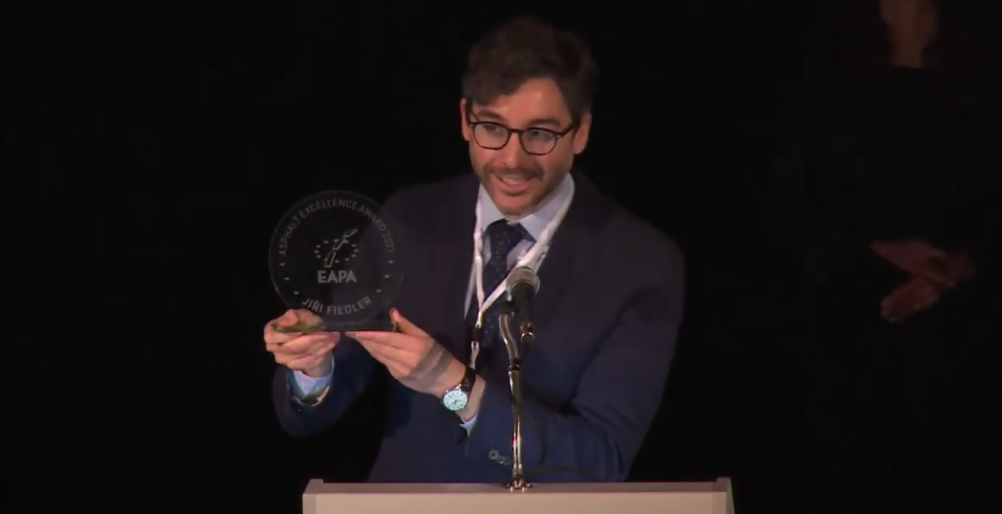
EAPA Director Breixo Gomez virtually handing over the trophy to Jiří Fiedler at AV’21 in Budweis
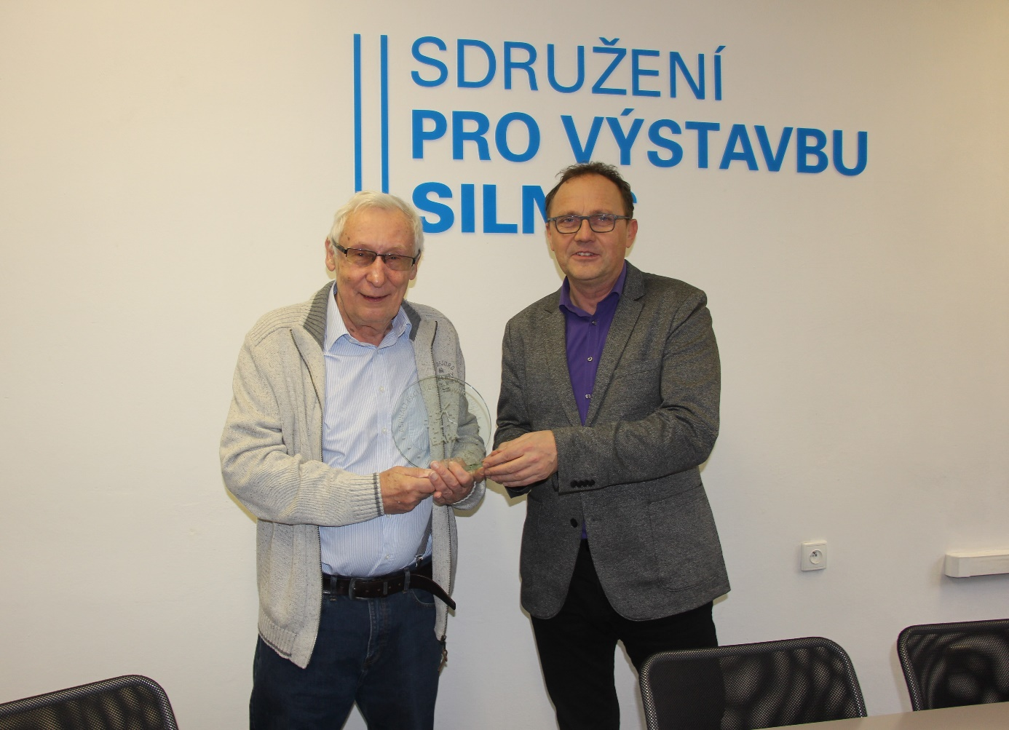
Jiří Fidler (left) receiving the trophy in Prague from Petr Svoboda from Czech Contractors Association and member of the EAPA Directors’ Group.
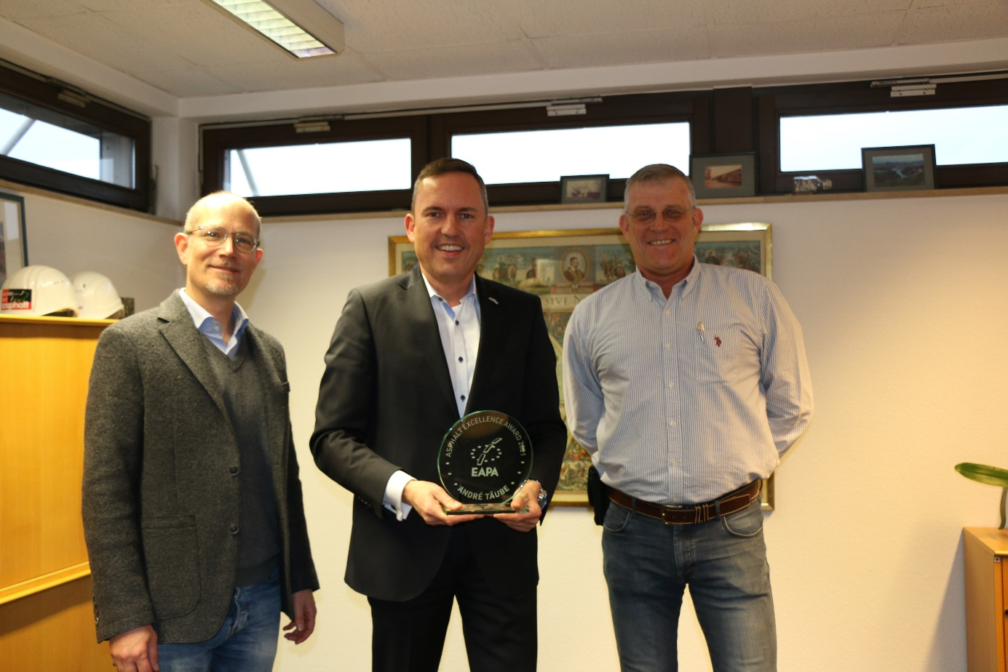
André Täube was honoured by EAPA Vice President Ralf Pomp (right) and EAPA Secretary General Carsten Karcher in the premises of DAV in Bonn
